A partnership with the Cystic Fibrosis Trust
Cystic fibrosis (CF) is a life-shortening genetic condition that causes the lungs and digestive system to become clogged with mucus as well as affecting almost every other part of the body. It affects over 10,400 people in the UK and currently there is no cure. People with CF often look perfectly healthy, but it’s a lifelong challenge involving a vast daily intake of drugs, time-consuming physiotherapy, and complete isolation from everyone else with the condition; despite that, many people with CF spend many weeks a year in hospital. The Cystic Fibrosis Trust is the only UK-wide charity dedicated to fighting for a life unlimited for everyone affected by cystic fibrosis. We do this by:
- Investing more money into cystic fibrosis than any other UK charity (over £3.5million a year).
- Driving up standards of clinical care and services for people affected by the condition.
- Offering trusted advice and support services on every aspect of life with cystic fibrosis.
- Raising awareness; we want everyone to know what CF is and how they can help.
- Campaigning; tackling the issues that matter to people with CF at the highest level.
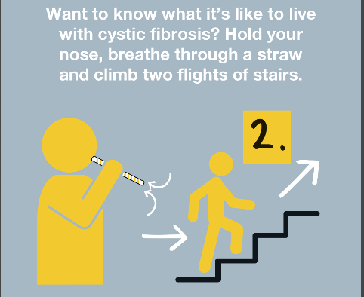
How you can support us
We want to expand our current portfolio of corporate partners and we would love to explore an exciting collection of licensed products with you. Our Strategic Partnerships team has a wealth of experience with corporate partners like you, and we will work together as part of a mutually beneficial relationship that engages your customers, motivates your employees and increases your brand awareness.
You can support us with:
- donations from bag sales
- royalties from licensed products
- product donation
- employee fundraising
- raising awareness of cystic fibrosis and the work of the Cystic Fibrosis Trust.
We’ll make it easy for you and your employees to get involved; together, we will create inspiring products that we will both benefit from. Your support is vital for us to continue our work lifting the limits that cystic fibrosis places on the lives of so many people in the UK every day.
From everyone at the Cystic Fibrosis Trust, we thank you for your consideration.
To find out more please contact Jacqueline Rogers, Senior Corporate Partnerships Manager, Jacqueline.rogers@cysticfibrosis.org.uk

