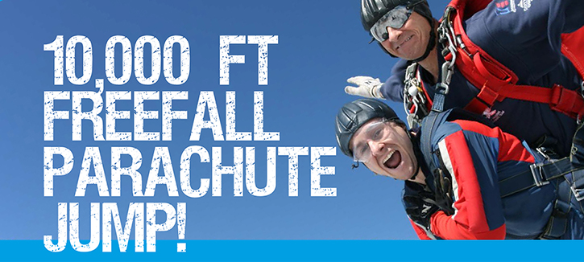

What is it like?
Imagine standing at the edge of an open doorway in an aircraft flying at 10,000 feet - the noise of the engines and the wind ringing in your ears with only the outline of distant fields below. Now imagine leaning forward out of that doorway and letting go - falling forward into the clouds, diving down through the air as you start freefalling at over 120mph! Then imagine the peace and quiet as the canopy opens, the steering toggles come down either side of you and you begin a tranquil parachute descent from a mile up in the air, steering yourself back down to the centre of the drop zone below. Imagine being able to do this for whilst harnessed to a professional freefall parachute instructor and at the same time being able to help a national charity! Stop imagining, it’s real and it’s happening all the time and you can be part of it...

What does the jump involve?
Technically the jump is called a ‘Tandem Skydive’. It is a Skydive because you will be freefalling through the air (without the parachute deployed) for several thousand feet; it is in Tandem because you will be always harnessed to a professional parachute instructor throughout the descent (see front photo). This is the only way you can jump from such an altitude without spending thousands of pounds becoming a freefall parachutist. This is literally the chance of a lifetime!

This jump is also much less demanding than the traditional ‘static line’ jump as the jump and training are completed in one day and your instructor will be in control of your landing.

Points to remember:
• Jump and training completed in one day
• Harnessed to an experienced parachute instructor at all times
• Jump from at least 10,000 feet - just like the professionals
• Freefall down to 5,000 feet - falling through the air at 120 mph!
• Ride the parachute down to the ground - we teach you how to steer onto the drop zone
• Landing controlled by your instructor
• Certificate to prove that you have completed a ‘two-mile high’ Tandem Skydive!

What must I do to qualify for a free jump?
All you have to do is raise £500 (or more!) for Cystic Fibrosis Trust by asking your friends and colleagues to sponsor you, using our specially designed sponsorship forms which you will find at the back of this information pack. Please do not be put off by this amount - if you ask everybody you know to sponsor you, you will find you can quite easily raise the minimum sponsorship and remember, every penny you raise over the minimum will be further contributing to Cystic Fibrosis Trust and giving you the chance to make an exhilarating freefall parachute jump.

What do I do next?
Read the page below entitled ‘Important Information’ and follow the link on the website to book your skydive day and location. After that all you have to do is make an exhilarating Tandem Skydive from 10,000 feet!

This is your chance to experience
120mph freefall!

IMPORTANT
INFORMATION

When can I jump?
We have organised a select number of dates for you to choose from, which are listed on the enclosed reservation form. If you are unable to jump on any of these dates please contact us on the number below to discuss the possibility of jumping on alternative dates.

Where is the airfield?
The British Parachute Association approved centres that we use are located across the UK and are indicated on the enclosed map. Once we have received your reservation form we will do our best to place you at your nearest available centre but if this is not possible we will contact you to discuss the alternatives.

Are there any restrictions on age or health?
For a tandem skydive you must be at least 16 years old and be under 15 stone in weight. Please note some centres have lower weight limits - please contact us for details. The principal medical restrictions are diabetes, epilepsy, fits, recurrent blackouts, heart or lung disease, mental illness and some cases of asthma. You will be required to sign a medical form before your jump declaring your fitness to take part - this will be sent to you upon receipt of your reservation form but is also available on request. Those under the age of 18 will need the medical form signed by a parent or guardian; those aged 40 and over, or those with a medical condition, will need it signed by their doctor.

Pre-existing physical conditions will not necessarily prevent you from taking part but please inform Skyline of any physical condition as this may affect the location of your jump. If you are in any doubt then please contact us for further information.

What about insurance?
You will automatically be covered for up to £2,000,000 third party insurance but this will not cover you for personal injury. Should you wish to take out cover for personal injury you should either arrange this through your own broker or you can contact us on the number below and we will send you a Personal Insurance Form.

How do I book my place for a jump?
Simply complete the enclosed reservation form and send it to us as soon as possible and certainly no later than the latest booking date indicated on the form. Please note you must also provide a £70 booking deposit made payable to ‘Skyline’ which can be taken out of your minimum sponsorship money.

Paying your sponsorship money
You have four weeks from the date of your jump before your money to charity is due. Full details of our sponsorship payment system are included on the following page entitled ‘Paying Your Sponsorship Money’.

Finally
We sincerely hope that you decide to give it a go - it has often been described as a thrilling ‘once in a lifetime’ experience and is an excellent way in which to raise funds for such a worthwhile cause. There will be lots of other people trying parachuting for the very first time on the day, so you are welcome to bring along your friends and family so they can watch you on a day you will simply never forget: The day you perform an exhilarating skydive or parachute jump in aid of Cystic Fibrosis Trust.

Fill in YOUR Reservation Form
NOW!

CHOOSE
YOUR
AIRFIELD

